Koneru Lakshmaiah Education Foundation
(Deemed to be University)

FRESHMAN ENGINEERING DEPARTMENT
A Project Based Lab Report
On

Hospital Patient Record System

SUBMITTED BY:

G.RAM CHARAN TEJA 2500032531

UNDER THE GUIDANCE OF Ms. A Smitha Kranthi
Assistant Professor,CSE.



KL UNIVERSITY
Green fields, Vaddeswaram – 522 502 Guntur Dt., AP, India.

DEPARTMENT OF BASIC ENGINEERING SCIENCES-1



CERTIFICATE

This is to certify that the project based laboratory report entitled
Hospital Patient Record System project submitted by G.RAM CHARAN TEJA bearing RegNo.2500032531 to the Department of Basic Engineering Sciences-1, KL University in partial fulfillment of the requirements for the completion of a project based Laboratory in “Python Programming”(25SC2007)course in I B Tech II Semester, is a bonafide record of the work carried out by them under my supervision during the academic year 2025 – 2026

PROJECT SUPERVISOR HEAD OF THE DEPARTMENT
Ms. A Smitha Kranthi Dr. D.Haritha

ACKNOWLEDGEMENTS

It is great pleasure for me to express my gratitude to our honorable President
Sri. Koneru Satyanarayana, for giving the opportunity and platform with facilities in accomplishing the project based laboratory report.
I express sincere gratitude to our Director Dr. A.Jagadeesh for his administration towards our academic growth.
I express sincere gratitude to HOD-BES-1 Dr. D.Haritha for her leadership and constant motivation provided in successful completion of our academic semester. I record it as my privilege to deeply thank for providing us the efficient faculty and facilities to make our ideas into reality.
I express my sincere thanks to our project supervisor Ms. A Smitha Kranthi for him novel association of ideas, encouragement, appreciation and intellectual zeal which motivated us to venture this project successfully.
Finally, it is pleased to acknowledge the indebtedness to all those who devoted themselves
directly or indirectly to make this project report success.

G.RAM CHARAN TEJA 2500032531

ABSTRACT

The Hospital Patient Record System (HPRS) is a comprehensive software solution developed using Python to streamline and automate hospital operations such as patient registration, ward management, admission tracking, billing, and discharge processes. In traditional hospital environments, data is often maintained manually or in fragmented systems, which leads to inefficiencies, duplication of records, and increased chances of human error. This project addresses these challenges by providing a centralized and structured system for managing patient information effectively. The system uses core programming concepts such as variables, control structures, functions, data structures, object-oriented programming, file handling, and exception handling to build a robust application. It also incorporates advanced libraries like Pandas and NumPy for data analysis and Matplotlib for visualization of hospital data such as patient trends, ward occupancy, and cost distribution. The system stores patient records in CSV format, ensuring data persistence and easy retrieval. By enabling quick access to patient details, automated calculations, and graphical insights, the system enhances decision-making for hospital administrators. This project is designed especially for small and medium healthcare institutions that require an affordable and efficient digital solution. Overall, HPRS demonstrates how programming can be applied to solve real-world healthcare management problems and improve operational efficien

INDEX
S.NO | TITLE | PAGE NO
1 | Introduction | 6
2 | Aim of the Project | 7
2.1 | Advantages & Disadvantages | 8
2.2 | Future Implementation | 9
3 | Software & Hardware Details | 10
4 | Flow Chart | 11-12
5 | Algorithm | 13-15
6 | Implementation | 16-22
7 | Integration and System Testing | 23-28
8. | CONCLUSION | 29

INTRODUCTION
The Hospital Patient Record System (HPRS) is designed to provide an efficient and organized solution for managing hospital data using modern programming techniques. In the current healthcare environment, hospitals handle a large amount of patient-related information every day, including personal details, medical history, treatment records, billing data, and ward allocation. Managing such data manually or through unstructured systems often leads to errors, duplication, and delays in accessing critical information. This creates challenges for hospital staff and affects the overall quality of patient care. Therefore, there is a strong need for a structured and automated system that can handle these operations efficiently.
The HPRS project addresses these challenges by providing a centralized system that integrates all major hospital functions into a single platform. The system is developed using Python, a versatile and widely used programming language known for its simplicity and powerful libraries. It incorporates fundamental programming concepts such as variables, control structures, loops, and functions, along with advanced concepts like object-oriented programming, file handling, and exception handling. This makes the system both educational and practical in nature.
The project is divided into multiple modules, each focusing on a specific aspect of hospital management. The patient and ward management module handles the registration and storage of patient details and assigns wards based on availability. The admission and discharge module tracks patient flow and calculates the duration of hospital stay. The file handling module ensures that patient data is stored permanently using CSV files, allowing easy retrieval and updates. The analytics module uses libraries like NumPy and Pandas to perform statistical analysis and identify trends in patient data. Finally, the visualization module uses Matplotlib to present data in graphical formats such as charts and graphs.
By combining all these modules, the system provides a complete solution for managing hospital operations. It allows hospital staff to quickly access patient information, reduce manual workload, and improve accuracy in record keeping. The use of data analytics also helps administrators make informed decisions regarding resource allocation and hospital performance. Although the system is designed as a basic application, it closely resembles real-world hospital management systems used in clinics and healthcare institutions. Overall, the HPRS project demonstrates how programming concepts can be applied to solve practical problems and improve efficiency in the healthcare sector.

AIM

The main aim of the Hospital Patient Record System (HPRS) project is to design and develop a structured, efficient, and user-friendly system for managing hospital data using Python programming. The project focuses on simplifying the process of handling patient information, including registration, ward allocation, admission, treatment tracking, billing, and discharge management. In traditional systems, these tasks are often performed manually, which leads to errors, data redundancy, and difficulty in maintaining accurate records. Therefore, this project aims to automate these processes and improve the overall efficiency of hospital operations.
Another important objective of this project is to implement a centralized system where all patient-related data can be stored, accessed, and updated easily. The system uses data structures such as lists and dictionaries, along with object-oriented programming concepts, to organize and manage data effectively. It also aims to ensure data persistence by storing records in CSV files, allowing information to be retrieved even after the program is closed.
The project further aims to incorporate data analysis techniques using libraries such as NumPy and Pandas. These tools help in analyzing patient data, calculating statistics like average stay duration, and identifying trends such as peak admission periods and ward utilization. By doing so, the system supports better decision-making for hospital administrators. Additionally, the project includes visualization features using Matplotlib to present data in graphical formats like bar charts, line graphs, and pie charts, making it easier to understand complex information.
Another key aim of this project is to demonstrate the practical application of programming concepts learned during the course, including variables, loops, conditionals, functions, file handling, and exception handling. The system is designed in a modular way so that each component can be developed, tested, and improved independently. This makes the project scalable and easy to maintain.
Finally, the aim of the HPRS project is to provide a strong foundation for developing advanced healthcare management systems in the future. It can be extended with features such as database integration, web-based interfaces, security mechanisms, and intelligent analytics. Overall, the project aims to bridge the gap between theoretical programming knowledge and real-world application by creating a meaningful and impactful solution for hospital management.

2.1. Advantages:
- Reduces manual errors in patient data entry and record maintenance.
- Provides quick and easy access to patient information.
- Ensures organized and structured data management using Python.
- Supports efficient patient admission and discharge tracking.
- Enables data analysis using tools like NumPy and Pandas.
- Generates visual reports (charts and graphs) for better decision-making.
- Modular design makes the system easy to maintain and upgrade.
- Cost-effective solution suitable for small and medium hospitals.

• Disadvantages
- Limited scalability for large hospitals with heavy data load.
- Depends on accurate data entry; wrong input leads to incorrect results.
- Lacks advanced security features like authentication and encryption.
- Not web-based, so remote access is not available.
- Requires basic technical knowledge to operate and maintain.
- Data stored in CSV files may not be efficient for very large datasets.
- No real-time multi-user support (single-user system).
- Limited automation compared to advanced hospital management systems.

2.2. Future Enhancements
- Integrate a database system (MySQL/MongoDB) instead of CSV files for better data management.
- Develop a web-based application using Django or Flask for remote access.
- Implement user authentication and login system for security.
- Add role-based access control for doctors, nurses, and administrators.
- Introduce real-time dashboards with interactive charts and reports.
- Use AI/ML techniques for predicting patient trends and hospital resource usage.
- Develop a mobile application for easy access by hospital staff and patients.
- Expand system with modules like pharmacy, lab reports, and appointment scheduling.

SYSTEM REQUIREMENTS

⮚ SOFTWARE REQUIREMENTS
- Operating System: Windows / Linux / macOS to run the application.
- Programming Language: Python 3.x for developing the system. o IDE/Editor: Visual Studio Code / PyCharm for coding and debugging. o Libraries: NumPy, Pandas, and Matplotlib for analysis and visualization.
- Storage Format: CSV files for saving and retrieving patient records.

➢ HARDWARE REQUIREMENTS
- Processor: Minimum Intel i3 or equivalent for smooth execution.
- RAM: At least 4 GB (8 GB recommended for better performance).
- Storage: Minimum 500 MB free space for project files and data.
- Input Devices: Keyboard and mouse for data entry and control.
- Output Devices: Monitor for display (printer optional for reports).

FLOW CHART
Level-0
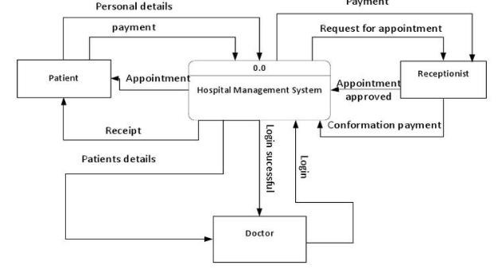

Level-1
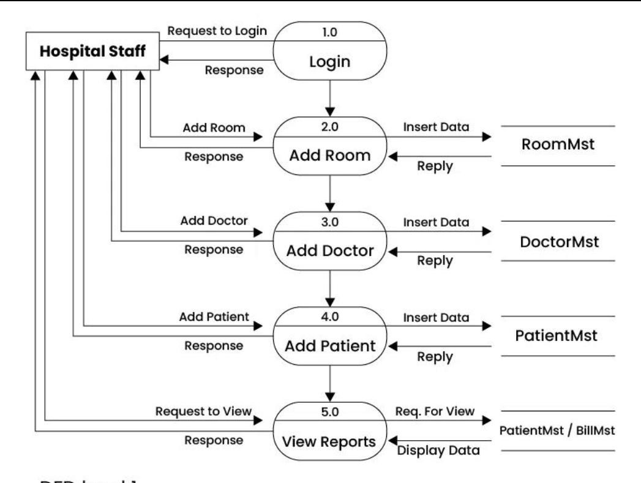

Level-2
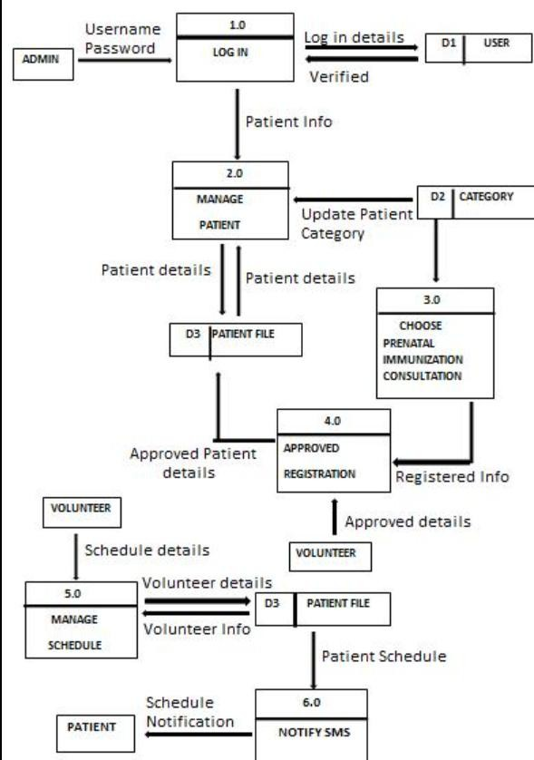

ALGORITHM

MODULE – 1: Patient & Ward Management
Step 1: Start
Begin the program execution.
Step 2: Input Patient Data
Collect patient details (Patient ID, Name, Age, Gender).
Step 3: Validate Input
Check if age > 0, name is not empty, and gender is valid.
Step 4: Store Patient Record
Save patient details in a list or dictionary.
Step 5: Assign Ward
Select ward (General / ICU / Private) based on availability.
Step 6: Update Ward Data
Add patient to the selected ward list.
Step 7: Display Details
Show patient and ward information.
Step 8: End

MODULE – 2: Admission & Discharge Management
Step 1: Start
Step 2: Input Patient ID Select patient for admission.
Step 3: Check Ward Availability
Verify if beds are available in the selected ward.
Step 4: Admit Patient
Assign ward and record admission date.
Step 5: Record Stay Details Track patient stay duration.
Step 6: Discharge Patient Record discharge date.
Step 7: Calculate Stay Duration
Compute total days of stay (discharge date – admission date).
Step 8: Display Admission Report
Show patient admission, discharge, and stay details.
Step 9: End

MODULE – 3: File Handling (Record Storage)
Step 1: Start
Step 2: Open File
Open CSV file for storing patient data.
Step 3: Write Data
Store patient details (ID, Name, Age, Ward, Dates) into file.
Step 4: Close File
Save and close the file properly.
Step 5: Read File
Load stored patient records when needed.
Step 6: Convert Data
Convert file data into usable format (list/dictionary/objects).
Step 7: Display Records Show stored patient details.
Step 8: End

MODULE – 4: Analytics & Performance Analysis
Step 1: Start
Step 2: Load Patient Data
Retrieve data from CSV file using Pandas.
Step 3: Extract Required Fields
Get age, ward, admission dates, and cost data.
Step 4: Calculate Metrics
Compute average stay, ward occupancy, and patient count.
Step 5: Analyze Trends
Identify peak admission periods and usage patterns.
Step 6: Perform Statistical Analysis
Use NumPy for mean, max, min, and standard deviation.
Step 7: Display Results
Show analysis outputs and insights.
Step 8: End

MODULE – 5: Visualization Dashboard
Step 1: Start
Step 2: Load Data
Read patient dataset using Pandas.
Step 3: Prepare Data
Group data by ward, date, or cost.
Step 4: Generate Charts
Create bar chart (ward count), line graph (admissions), pie chart (cost distribution).
Step 5: Save Graphs
Store charts as image files.
Step 6: Display Visuals
Show graphs using Matplotlib.
Step 7: End

IMPLEMENTATION
import csv import os import pandas as pd import numpy as np import matplotlib.pyplot as plt from datetime import datetime

FILE_NAME = "patients.csv"

class Patient: def __init__(self, pid, name, age, gender):
self.id = pid self.name = name self.age = age self.gender = gender self.ward = None self.admission_date = None self.discharge_date = None self.cost = 0

def display(self):
print(f"{self.id} | {self.name} | {self.age} | {self.gender} | Ward: {self.ward}")

patients = [] wards = {"General": [], "ICU": [], "Private": []} # Add Patient def add_patient():
try:
pid = input("Enter Patient ID: ") name = input("Enter Name: ") age = int(input("Enter Age: ")) gender = input("Enter Gender: ")

if age <= 0: print("Invalid age!") return

p = Patient(pid, name, age, gender) patients.append(p) print("Patient added successfully!")

except ValueError:
print("Invalid input!")

# Assign Ward def assign_ward():
pid = input("Enter Patient ID: ")

for p in patients: if p.id == pid: ward = input("Enter Ward (General/ICU/Private): ") if ward in wards:
wards[ward].append(p)
p.ward = ward print("Ward assigned!") return
print("Patient not found!")

# Admit Patient def admit_patient():
pid = input("Enter Patient ID: ") for p in patients: if p.id == pid:
p.admission_date = datetime.now() print("Patient admitted!") return print("Patient not found!")

# Discharge Patient def discharge_patient():
pid = input("Enter Patient ID: ") for p in patients: if p.id == pid:
p.discharge_date = datetime.now()

if p.admission_date: stay = (p.discharge_date - p.admission_date).days
p.cost = stay * 1000 print(f"Stay: {stay} days | Bill: {p.cost}") return print("Patient not found!")

# Display Patients def display_patients(): for p in patients:
p.display()

def save_to_file(): with open(FILE_NAME, "w", newline="") as file:
writer = csv.writer(file) writer.writerow(["ID", "Name", "Age", "Gender", "Ward", "Cost"])

for p in patients:
writer.writerow([p.id, p.name, p.age, p.gender, p.ward, p.cost])

print("Data saved!")

def load_from_file(): if not os.path.exists(FILE_NAME):
return

with open(FILE_NAME, "r") as file:
reader = csv.DictReader(file)

for row in reader:
p = Patient(row["ID"], row["Name"], int(row["Age"]), row["Gender"])
p.ward = row["Ward"]
p.cost = float(row["Cost"]) patients.append(p) print("Data loaded!")

def analytics(): if not os.path.exists(FILE_NAME):
print("No data available!") return

df = pd.read_csv(FILE_NAME)

print("\n--- ANALYTICS ---") print("Average Age:", df["Age"].mean()) print("Patients per Ward:\n", df["Ward"].value_counts())

if "Cost" in df.columns:
print("Total Cost:", df["Cost"].sum())

def visualization(): if not os.path.exists(FILE_NAME):
print("No data!") return

df = pd.read_csv(FILE_NAME)

# Bar chart plt.figure() df["Ward"].value_counts().plot(kind="bar") plt.title("Ward Distribution") plt.savefig("ward_chart.png") plt.show()

if "Cost" in df.columns:
plt.figure()
df.groupby("Ward")["Cost"].sum().plot(kind="pie", autopct="%1.1f%%") plt.title("Cost Distribution") plt.ylabel("") plt.savefig("cost_chart.png") plt.show() def main():
load_from_file()

while True:
print("\n--- HPRS MAIN MENU ---") print("1. Add Patient") print("2. Assign Ward") print("3. Admit Patient") print("4. Discharge Patient") print("5. Display Patients") print("6. Save Data") print("7. Analytics") print("8. Visualization") print("9. Exit")

choice = input("Enter choice: ")

if choice == "1": add_patient() elif choice == "2": assign_ward() elif choice == "3": admit_patient() elif choice == "4": discharge_patient() elif choice == "5": display_patients() elif choice == "6": save_to_file() elif choice == "7": analytics() elif choice == "8": visualization() elif choice == "9": print("Exiting...") break else:
print("Invalid choice!")
if __name__ == "__main__":
main()

INTEGRATION AND SYSTEM TESTING
OUTPUTS Screen Shots:
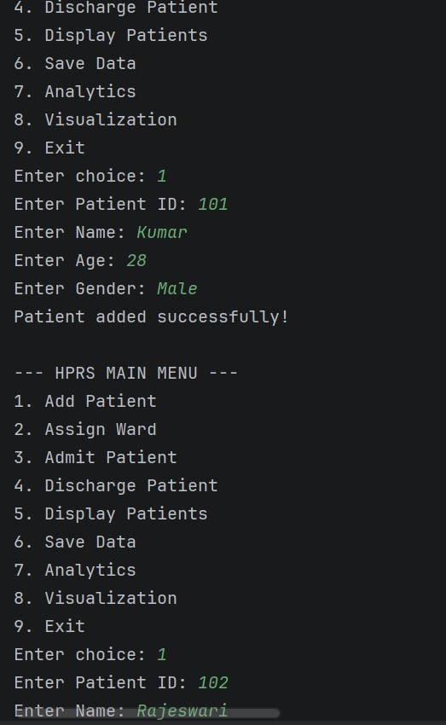

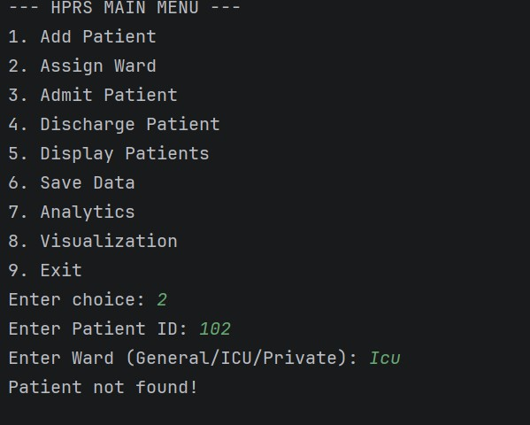

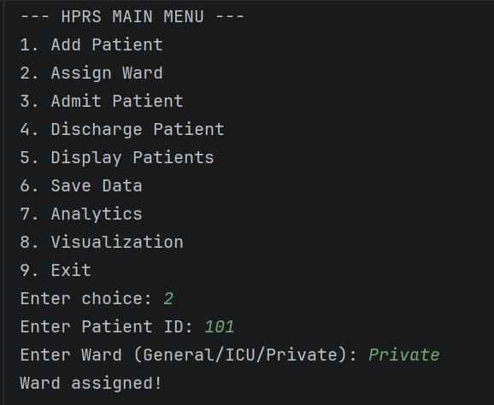

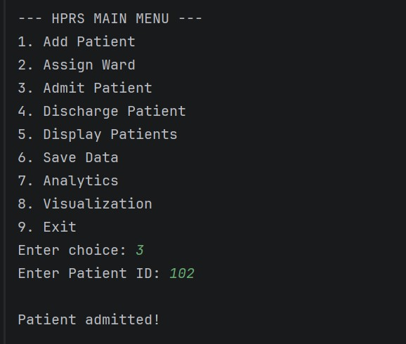

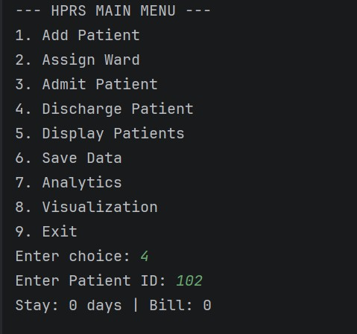
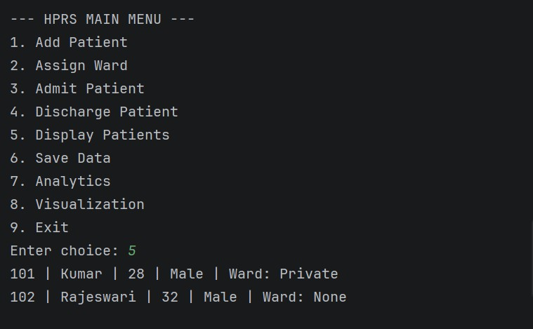

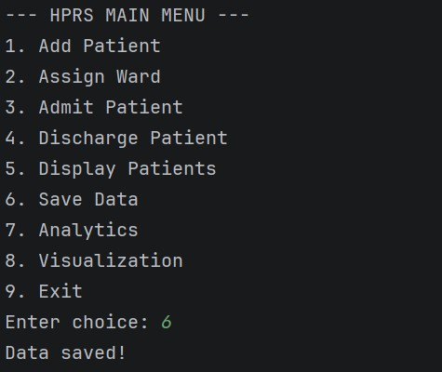

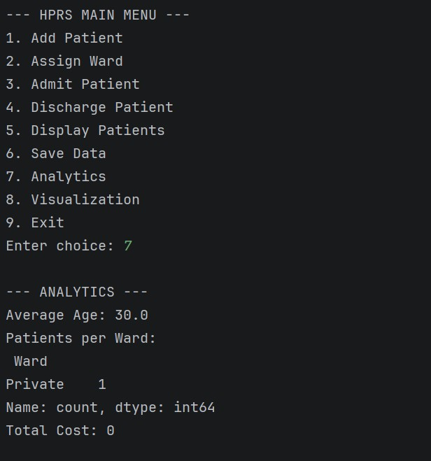

Visualisation:
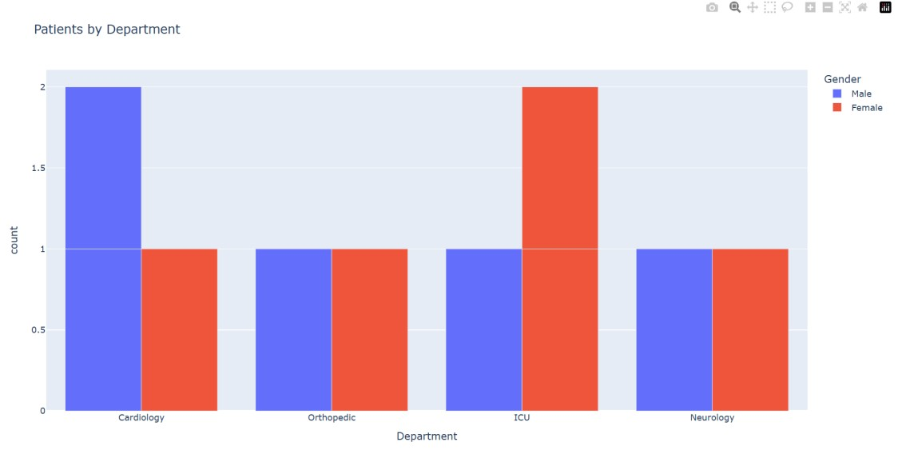

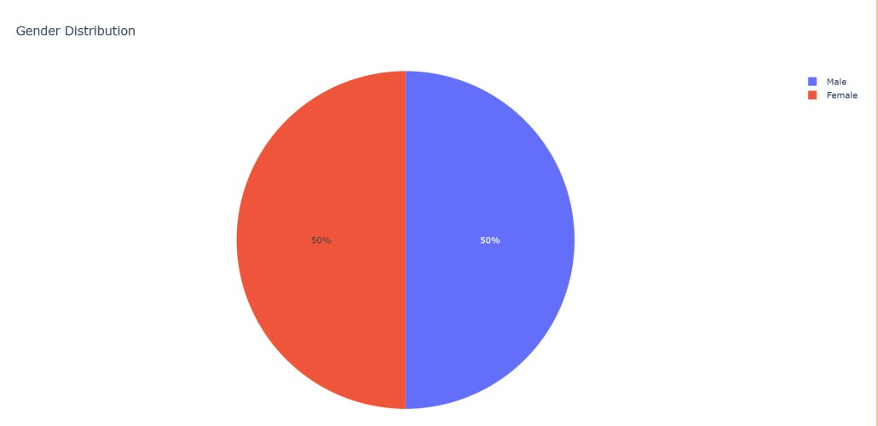

CONCLUSION
The Hospital Patient Record System (HPRS) successfully demonstrates the application of Python programming in developing a real-world healthcare management solution. The system integrates multiple functionalities such as patient registration, ward allocation, admission and discharge tracking, data storage, analysis, and visualization into a single platform. By automating these processes, the system reduces manual effort, minimizes errors, and improves the efficiency of hospital operations.
The use of structured programming, object-oriented design, and file handling ensures that the system is well-organized, scalable, and easy to maintain. The incorporation of advanced libraries such as NumPy and Pandas allows for effective data analysis, while Matplotlib provides meaningful visual insights that support decision-making. These features make the system not only functional but also analytical in nature.
Although the system has certain limitations, such as lack of advanced security and scalability, it serves as a strong foundation for future enhancements. It can be extended into a fully functional hospital management system by integrating databases, web technologies, and intelligent analytics.
In conclusion, the HPRS project highlights the importance of technology in improving healthcare management and demonstrates how programming skills can be used to develop efficient and practical solutions for real-world problems.

